**BME2104 -《生物医学影像技术》Home Work #1**

Due Date: March 20th, 2024

***Note:*** *Please prepare your answers to the problems in a single PDF, and upload your PDF to Blackboard.*

**Problem 1:**

A cycle of a square wave can be expressed as following equation

$$f\left(x\right)=\left\{\begin{matrix}1, & 0≤x<1/2 \\ 0, & 1/2≤x<1\end{matrix}\right.$$

Using Fourier Series, please do analytical derivation to prove that this square wave can be represented as a linear combination of sine waves of different frequencies.

Then, using a programming environment of your choice (MATLAB/Python), please build a numerical model to demonstrate that the above square wave is indeed a linear combination of sine waves. Please use plots to help explain.

**Problem 2:**

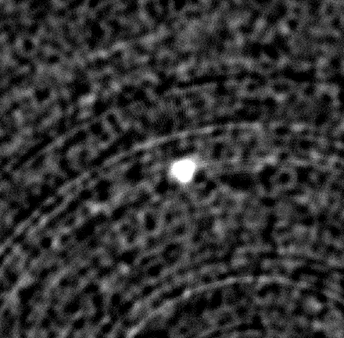A micro-CT imaging system’s spatial resolution was characterized with a thin tungsten wire phantom. An axial micro-CT slice image of the phantom is shown here (original image file is uploaded to Blackboard, ” MTF-slice”. Note the pixel size is 7.6um).

(1). Please plot the Line Intensity Profile (LIP) of the wire in the center of the image. Please fit the LIP with a Gaussian function.

(2). Assume that the diameter of the wire is very small, therefore the LIP can be assumed to be the LSF of the micro-CT. Using the LSF, please calculate the MTF of the micro-CT. Please plot the MTF, and fit your MTF with a Gaussian function. Is your Gaussian function in (2) close to the FT (Fourier Transform) of the Gaussian function in (1)? Find your spatial resolution at 10% MTF? Explain your result.

**Problem 3:**

Start with any noisy digital image (it can be downloaded from the web, synthesized by yourself, or even an image in your smartphone), first convert it into 8-bit grey scale if it is not already so, then re-size it to 512 x 512 using digital down-sampling or up-sampling (combined with cropping/padding if necessary), you will end up with a noisy grey-scale image of 512 x 512. Then, do image denoising using the following two approaches:

(1). Filtering in frequency space: First find the FT version of the image, then multiply the FT version with a low-pass filter, which will give you a filtered FT version. Finally do an inverse FT to yield the denoised image. Please try with low-pass filters of different filtration levels, and show your results.

(2). Filtering in image space: design a ‘smoothing/denoising’ filter kernel, and convolute it with the noisy grey-scale image to receive your denoised image.

(3). For the above two denoising approaches, calculate their respective MSE, PSNR, and SSIM relative to the original image before denoising.